PROJECT DESIGN PHASE
Solution Architecture
Date | 06 September 2026 | Name | V.Maheswari
Project Name | Incident Lifecycle Automation in ServiceNow | Maximum Marks | 4 Marks
Solution Architecture:
The proposed architecture bridges the incident-management business problem and the ServiceNow technology solution. It defines the structure, behavior, workflow, integrations, and delivery requirements needed to automate the complete Incident Management lifecycle.
Architecture Goals
• Find a suitable technology solution for structured incident handling and faster resolution.
• Describe the structure, characteristics, and behavior of the ServiceNow Incident workflow for project stakeholders.
• Define features and requirements for creation, classification, assignment, investigation, resolution, change handling, child incidents, and knowledge reuse.
• Provide specifications for managing incidents, SLAs, escalations, and service visibility.
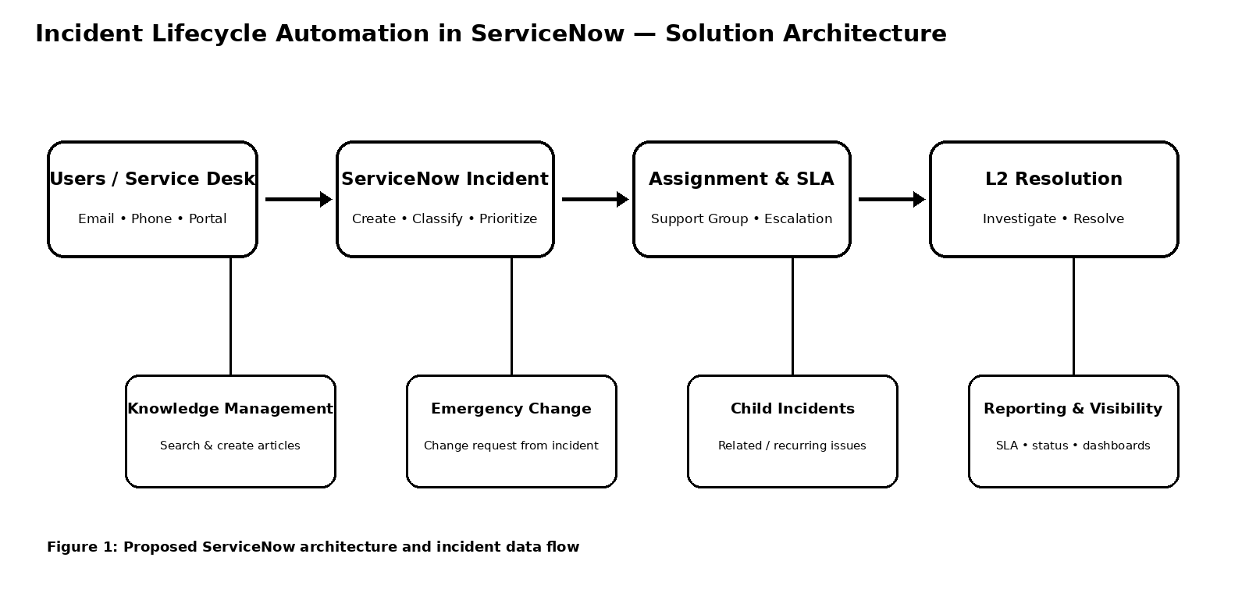
Figure 1: Proposed ServiceNow architecture and incident data flow
Architecture Components&Flow
Incident Intake: Service Desk creates the incident and captures required details.
Incident Management: Classification and prioritization establish the correct handling path.
Assignment & SLA: Incidents are routed to the appropriate support group with SLA tracking and escalation.
L2 Support: Level 2 technicians investigate, document work, and resolve the incident.
Connected Capabilities: Knowledge Management supports faster resolution; emergency change requests and child incidents are created when required.
Knowledge & Reporting: Resolved incidents can generate reusable knowledge, while status and SLA reporting improve service visibility.
Reference: Provided Solution Architecture template and Incident Lifecycle Automation requirements.

